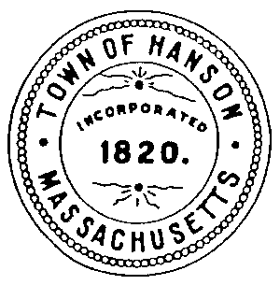
Hanson Board of Health
Town Hall
542 Liberty Street
Hanson, MA 02341
(781) 293-3138
www.hanson-ma.gov
December 2015

Helpful information for disposal of holiday items at the Hanson Transfer Station.

Greeting cards and wrapping paper: Greeting cards, envelopes and gift wrap with metallic foil should not be recycled with paper. These items must be disposed of in the Town approved orange bags or;
- St. Jude's Ranch for Children recycles your used greeting cards and creates new holiday and all-occasion greeting cards. Recycled cards are sold to support programs and services for abused, neglected and homeless children, young adults and families.

Holiday Lights: Strings of lights and other items with cords should not be disposed of in single stream recycling. They tangle in the equipment. These items must be disposed of in the Town approved orange bags or;

Your electronics recycler will happily accept holiday lights for recycling. Please remove large bulbs (>1").
- Best Buy accepts holiday lights and other small appliances. Bring items to Customer Service.
- Holiday lights can be sent to HolidayLEDs.com in exchange for a coupon for new energy efficient LED holiday lights during their seasonal holiday light recycling program. They also take power cords, speaker wire, and peripheral connectors. The proceeds from recycling used holiday lights sent to Christmas Light Source are used to donate books to Toys for Tots.

Styrofoam® (expanded polystyrene, EPS), and other foams: Foam materials make a mess in the sorting facilities (as do plastic bags), so are not recyclable with single stream recycling. These items must be disposed of in the Town approved orange bags or;
Many pack-and-ship stores (UPS, Kinkos, FedEx, etc.) accept expanded polystyrene "peanuts" and other packing materials for reuse.
Insulation Technology, Inc, 35 1st St, Bridgewater, serves as a collection point for ReFoamIt (below). Leave clean, bagged material in their foyer any time.
ReFoamIt, 25 Mohawk Dr., Warehouse 2, Leominster, MA, accepts and recycles the following CLEAN, DRY foam materials:
- #6 EPS Foam
- White packing foam (recycling symbol is not required)
- Colored packing foam (recycling symbol is not required)
- Foam used with food and beverage items (recycling symbols #4,5, or 6 IS required)
- Bubble wrap for reuse
- Packing peanuts for reuse
- ReFoamIt also runs one-day collections, click here for upcoming events.

When choosing packing material, bubble wrap is more easily recycled (with plastic bags) and reused.

