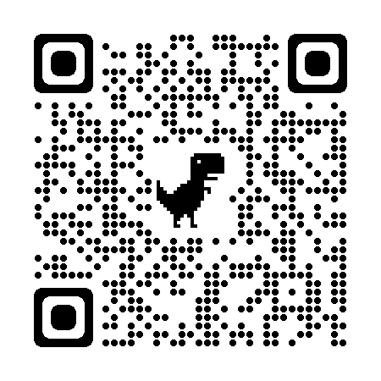

QR CODE – INDIAN CROSSWAY

