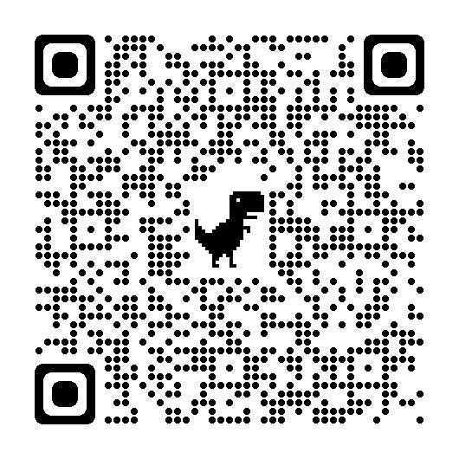

QR CODE – POOR MEADOW BROOK LOOP TRAILS

