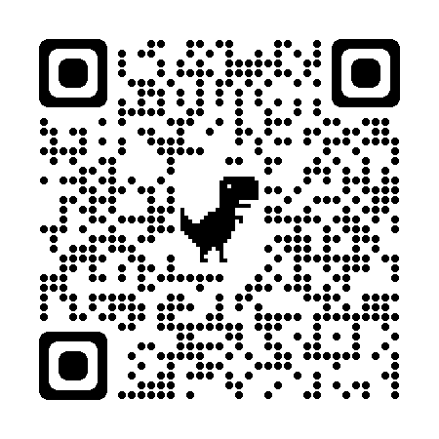

QR CODE – Webster Billings Conservation Area

